RESOLUTION NO.__________

RE: CERTIFICATE OF APPROPRIATENESS UNDER THE
PROVISIONS OF THE ACT OF THE PENNSYLVANIA
LEGISLATURE 1961, JUNE 13, P.L. 282 (53
SECTION 8004) AND BETHLEHEM ORDINANCE NO.
3952 AS AMENDED.

WHEREAS, it is proposed to install signs at 312 E. Third St.

NOW, THEREFORE, BE IT RESOLVED by the Council of the City of Bethlehem that a Certificate of Appropriateness is hereby granted for the work.

Sponsored by: (s)

(s)

ADOPTED BY COUNCIL THIS DAY OF

(s)
President of Council

ATTEST:

(s)
City Clerk

HISTORIC CONSERVATION COMMISSION

CASE # 535 – It is proposed to install signs at 312 E. Third Street
OWNER/APPLICANT: Polk St Development Assoc/ Signarama Lehigh Valley

The Commission upon motion by Mr. Evans seconded by Mr. Cornish adopted the proposal that City Council issue a Certificate of Appropriateness for the proposed work described herein:
- The proposal to install signs at 312 E. Third St. was presented by Steve Stigliano.
- The new wall sign will read “Upscale Stylez” with “Upscale” in purple lettering and “Stylez” in teal lettering. The letters will have a white outline
- The letters will be mounted to the wall with approximately ½” standoffs and will be halo/ back lit.
- The sign will be approximately 27” high x 109” wide.
- Vinyl door and window signage will also be installed. The door signage will be white as proposed.
- Window ribbon signs will be installed in lower third of window. The ribbon signs will be 6” x 33.5” each and placed in the three windows on the left of the door in teal and in three windows on the right in purple.
- The proposed motion was unanimously approved.

CU: cu
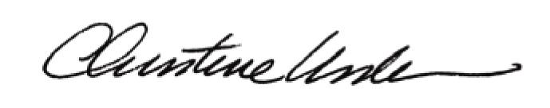

By:

Date of Meeting: March 16, 2015 Title: Historic Officer

